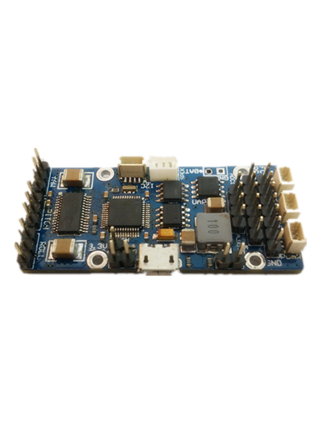

THE TINY PRO BOARD

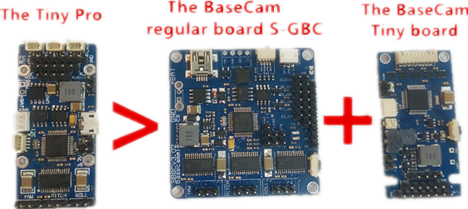

Feature：
The smallest size
The latest DC module
One IMU On board
SPEK INTERFACE
The Max current 2.5A/each motor
SH1.0 encoder interface （PWM)
SIZE: 54x25mm

Details：
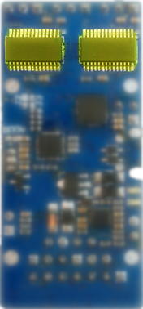
Current: The drive of the motor use DRV8313
(the same as BaseCam regular board S-BGC)，
continuous current 1.75A for each motor, the
Max current 2.5A for each motor

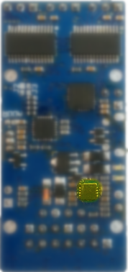
Voltage: Used the latest DC module, the Max
voltage can up to 40V,(Recommend the use of
6S battery), We used the latest High current
3.3V module, it will more Safety when you use
External equipment.

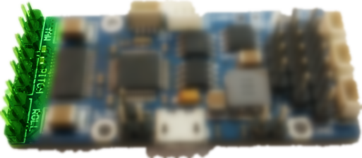
Motor interface:
optimize for high current demand
and same method like S-BGC.

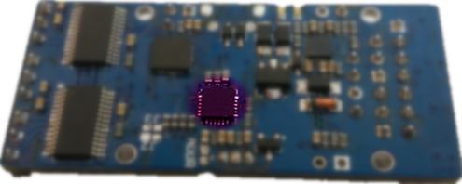
The IMU on board:
it have a master-slave jumper
settings, You can use it for Frame or Camera
Just need cut the jump as the picture,you can get the
Frame IMU

SPEK INTERFACE:
Support Spectrum Satellite receiver (same function as S-BGC)
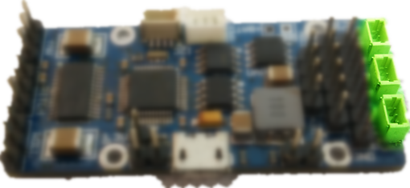

J2 and J3 jumper：
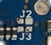
Used Basecam newest I2C-Drive hardware design
and can ensure tiny pro can work more stable

SH1.0 Encoder interface(PWM) :
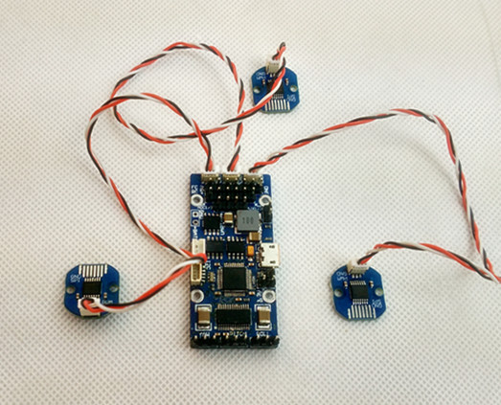
Special independent
Multiplexing encoder interface ,
easier to wire compare with
Other board in the market

RC interface :
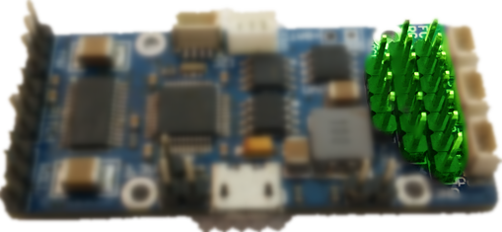
Same circuit layout as basecam
tiny board ,maxiumize to reduce
board size.

Series interface :
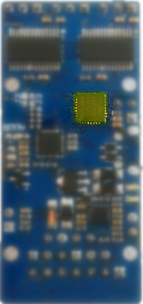
More stable when connect with PC than
standard tiny board cause we used
CP2102 chip(same as S-BGC) but
tiny board applied ST simulate interface .

The CNC enclosure :


